SUPPLEMENTARY REGULATIONS
SPEED and NON SPEED EVENTS 2021
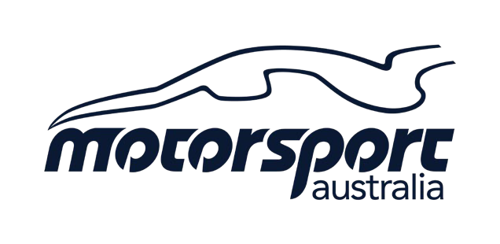

NAME OF EVENT: | Coffs Coast Motorkhana. Rnd 1.
TYPE OF EVENT: | Motorkhana
VENUE/LOCATION: | Raleigh Raceway. Valery Road. Raleigh. NSW. 2454.

The event will be conducted under the International Sporting Code of the FIA., the National Competition Rules of Motorsport Australia., the Speed and Non-Speed Event Standing Regulations, the National/State Championship or Series Regulations relevant to the event, The Motorsport Australia Motor Sport Passenger Ride Activity (MSPRA) Policy the Motorsport Australia Come and Try Policy, these Supplementary Regulations and any further Supplementary Regulations or Bulletins which may be issued. This Event will be conducted under and in accordance with Motorsport Australia OH&S, Safety 1st and Risk Management Policies. This Event will be conducted under and in accordance with any and all of the current Motorsport Australia COVID-19 Ready to Race strategy requirements, which can be found on the Motorsport Australia website at www.motorsport.org.au. Certain public, property, professional indemnity and personal accident insurance is provided by Motorsport Australia in relation to the event. Further details can be found in the Motorsport Australia Insurance Handbook, available at www.motorsport.org.au.

EVENT START DATE | 23-05-2021 | PERMIT NUMBER | 221/2305/08
EVENT FINISH DATE | 23-05-2021

ORGANISING CLUB/PROMOTER: | Coffs Harbour & District Sporting Car Club Inc.
ORGANISING COMMITTEE: | Coffs Harbour & District Sporting Car Club
ADDRESS: | Po Box 101. Coffs Harbour. NSW. 2450
EMAIL: | mickmorley@outlook.com

CLERK OF COURSE | Michael Morley |  | MEMBER ID | 9938355
SECRETARY | Michael Morley |  | MEMBER ID | 9938355
SCRUTINEER | John Kelly |  | MEMBER ID | 9338579
TIMEKEEPER | TBA |  | MEMBER ID
JUDGE OF FACT | TBA |  | MEMBER ID
COVID-19 CHECKER |  | TBA | MEMBER ID

ENTRIES OPEN: | On publication of sup regs |  | ENTRIES CLOSE: | 23-05-2021
ENTRY FEES: | Adults $30.00  Juniors $15.00 |  | MIN & Max ENTRY: | 8 Min – 40 Max. Max 3 Entries per Car.
MINIMUM LICENCE REQUIREMENTS: |  |  | L2NS (L2NSJ) | Event Start Time | 9.45am
DRIVERS BRIEFING TIME: |  | 9.30am | LOCATION: | Raleigh Raceway, Lower Paddock
SCRUTINEERING TIME: |  | 8.00am | LOCATION: | Raleigh Raceway, Lower Paddock

- EVENT REQUIREMENTS:
- Rally tyres or winter tread tyres are NOT permitted.
- All vehicles must comply with Schedule A and Group 4H of the current Motorsport Australia Manual.
- Approved helmets and apparel, in accordance with Schedule D of the current Motorsport Australia Manual.
- Fuel must be in accordance with Schedule G of the current Motorsport Australia Manual.
- Cars must be adequately muffled.
- Competitors must produce a valid and current:| Motorsport Australia Competition | Licence Club Membership Card of a Motorsport Australia Affiliated Car Club | Log Book (if issued).

PRIZES & TROPHIES:
1st, 2nd,3rd Outright
1st in Class
Junior 1st, 2nd, 3rd
Ladies 1st, 2nd, 3rd

Classes
A | 2WD wheelbase up to 2150mm.
B | 2WD wheelbase 2151 to 2390mm.
C | 2WD wheelbase 2391 to 2574mm.
D | 2WD wheelbase 2575 and over.
E | 4WDvehicles (which must be driven in the four- wheel drive mode throughout the competition).
F | Front-Wheel Drive Specials.
G | Rear Wheel Drive Specials

- SCHEDULE/ OTHER EVENT REQUIREMENTS:

- Entries will be accepted in order of receipt unless otherwise specified

- The organisers may refuse any entry in accordance with the NCR’s of the current Motorsport Australia Manual.

- Entries from competitors under 18 years of age must be counter signed / consented to by a parent/ guardian.

- Event organisers reserve the right to cancel, abandon or postpone the event in accordance with the NCR’s of the current Motorsport Australia Manual.

- Protests must be lodged in accordance with the NCR’s of the current Motorsport Australia Manual.

The holder of a Motorsport Australia Licence (or a Licence issued by another ASN) may be tested for the presence of any drug or other banned substance and subject to a penalty for a breach of the Australian National Anti-Doping Policy and/or the Motorsport Australia Illicit Drugs in Sport (Safety Testing) Policy at www.motorsport.org.au.
Consumption of alcohol in the paddock, pits or any other Reserved Area is prohibited until all Competition is concluded each day. The holder of a Motorsport Australia Licence (or a Licence issued by another ASN) may be tested for the presence of alcohol by a Motorsport Australia Accredited Testing Official (CATO) in accordance with the Motorsport Australia Alcohol Policy at www.motorsport.org.au

