Spectator Point
COFFS COAST RALLYSPRINT 2016
Proundly Sponsored By
Woolgoolga 
BP Woolgoolga Service Centre
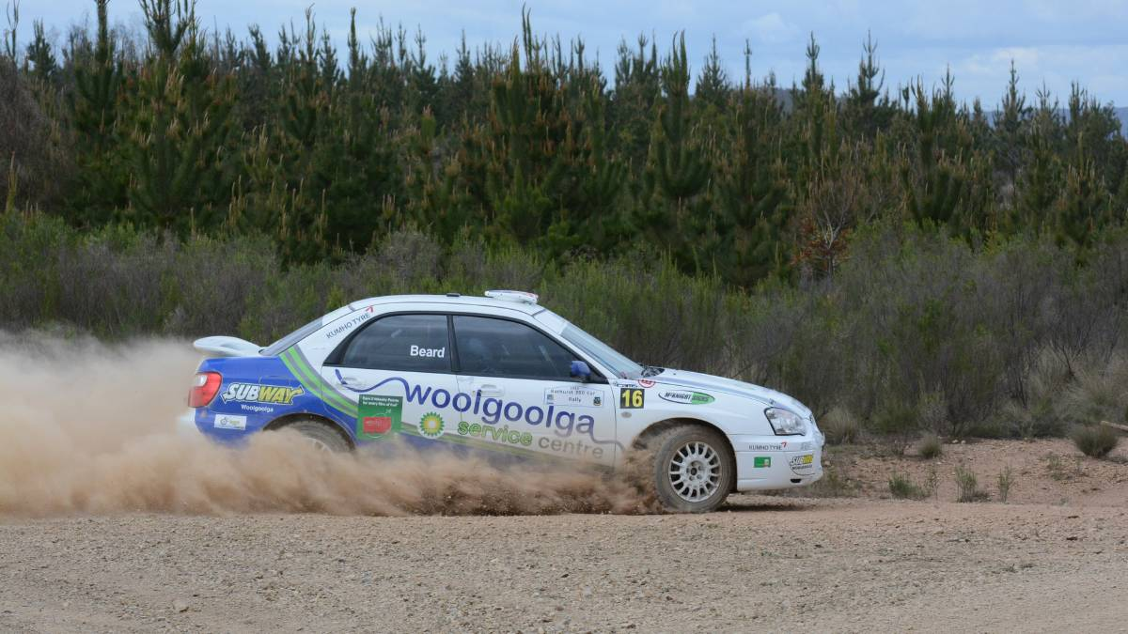



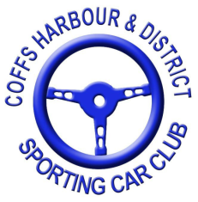
Presented by Coffs Harbour & District Sporting Car Club
Celebrating 50 yrs 1966-2016

Supported by
Tyres Urunga North Coast Marine Centre
Urunga Waters Tourist Park Hickeys Garage & Service Station

Directions How To Get To Specy Point
Ainsworth Rd ROUGH RD

SPECY POINT
SERVICE PARK
VALLA BEACH
URUNGA
Ballards Rd
Range Rd
Pacific Hwy

Martels rd

NO ACCESS Rally Cars Only

Parking

Veiwing
NO GO AREA IN RED

Once you have reached the specy point park in a appropriate spot keeping the road clear for official vehicles and please follow the directions of the officials to keep in a safe veiwing point for your enjoyment of motorsport
WARNING Motorsport is a dangerous sport for spectating always stay in a safe place

